The Lighthouse

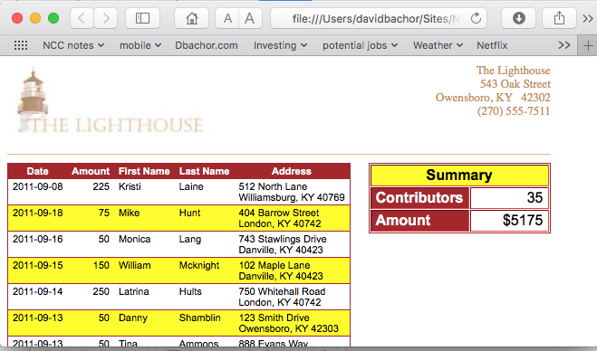

The Lighthouse is a charitable organization located in central Kentucky that matches donors with needy groups. The fundraising coordinator for The Lighthouse want to display a list of information on recent donations, including the name and address of the donor, the amount donated, and the date of the donation. A list of donations has been stored in a collection of arrays named firstName, lastName, street, city, state, zip, amount and date. The fundraising coordinator wants the data from those arrays displayed in a web table. Also, a summary table is needed to display the total number of contributors and the total amount donated. The picture above shows what the final result should look like.

Complete the Following:

1. Using your text editor, open clisttxt.html, enter your name and date in the head section and save the file as clist.html
2. The firstName, lastName, street, city, state, zip, amount and date arrays have been created and populated in the list.js file. In the head section of the document, insert a script element that points to this file.
3. Below the script element you just created, insert another script element that contains the function amountTotal(). The purpose of this function is to return the sum of all of the values in the amount array. There are not parameters for this function. Add the following commands to this function:
   1. Declare a variable named total, setting its initial value to 0;
   2. Create a For Loop that loops through all of the values in the amount array. At each iteration of the loop, add the current value of the array item to the value of the total variable.
   3. After the For Loop is completed, return the value of the total variable;
4. Scroll down the document and locate the div element with the ID data_list. Within the div element, add a script element that contains the following commands:
5. test
   1. Write the following code to the document to create the header row for the table of contributions:

<table border=’1’ rules=’rows’ cellspacing=’0’>

<tr>

<th>Date</th>

<th>Amount</th>

<th>First Name</th>

<th>Last Name</th>

<th>Address</th>

</tr>

* 1. Create a For Loop in which the counter variable starts at 0, while the counter is less than the length of the amount array, increase the counter in increments of 1.
  2. Display every other row in the table with a yellow background. To do this, within the For Loop, insert an if condition that tests whether the counter variable is divisible evenly by 2 (Hint: Use the % modulus operator) If the counter variable is divisible by 2, write the following HTML tag.

<tr>

Otherwise, write the following tag:

<tr class=’yellowrow’>

1. Next, within the For Loop, write the HTML code

<td>***data***</td>

<td class=’amt’>***amount***</td>

<td>***firstName***</td>

<td>***lastName***</td>

To the document where ***date***, ***amount***, ***firstname*** and ***lastName*** are the values from the data, amount, firstName and lastName arrays for the index indicated by the current value of the For Loop’s counter variable.

1. Finally, within the For Loop, write the HTML code

<td>***street***<br /> ***city, state zip*** </td>

</tr>

to the document, where ***street***, ***city***, ***state*** and ***zip*** are the values from the street, city, state and zip arrays for the current index value.

1. Go to the div element with the ID totals. Insert a script element that writes the HTML code

<table border='1' cellspacing='1'> <tr>

<th id='sumTitle' colspan='2'> Summary </th></tr><tr> <th>Contributors</th> <td>***contributions***</td></tr><tr> <th>Amount</th> <td>$***total***</td></tr>

</table>

to the document , where ***contributions*** is the length of the amount array and ***total*** is the values returned from the amountTotal() function your created earlier.

1. Close the file, saving your changes
2. Open Clist.html in your browser and verify that a list of 35 contributions totaling $5175 is displayed in the table and that the alternate rows of the contributor list have a yellow background.
3. Submit your completed web site to blackboard.